**Overview of retail application**

Throughout this course, you'll be building a small shopping cart application using the MEAN Stack. Users of this application will be able to browse through products, add products to their cart, and even check out using the stripe API.

The final application will be structured something like this.

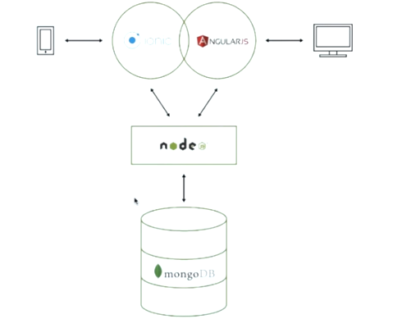

You will have a Node.js server that stores data in MongoDB. On top of that you will have two clients, an angular JS client that runs in a browser like Google Chrome, and a hybrid mobile app built using the ionic framework. These clients will both interact with the server through an API.

The application you will build will essentially be a simplified Amazon. You'll have products organized by category. You can then look at a single product, add the product to your cart, and then check out via fake payment.

Again, this application will have three views--

The category view that lists products that belong to a particular category,

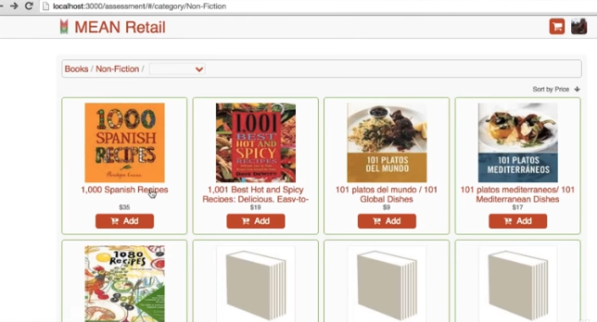

The product view, which displays detailed information about a single product,

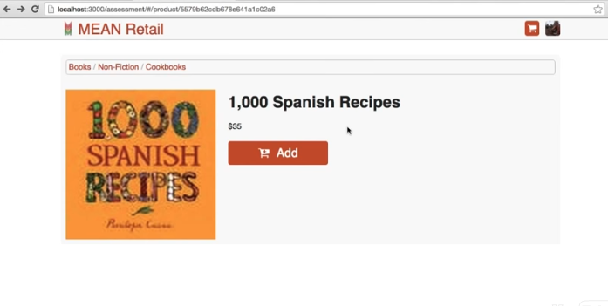

And the cart view, which shows the current items that the logged in user has added to their cart.

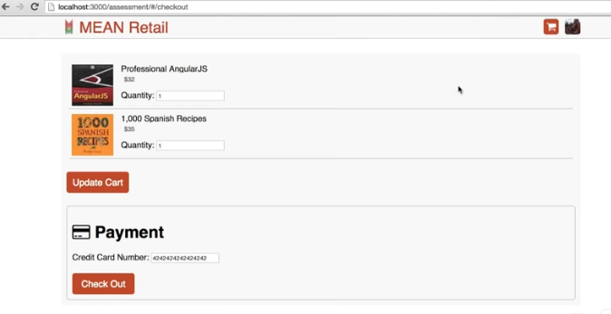

The cart will also enable the user to perform a fake payment processing.

This app will be structured as a single page app, which means that AngularJS will be responsible for rendering HTML by themselves. There will be no page reloads in this application. AngularJS will be responsible for routing between the different views in your application.

The AngularJS client will communicate with the Node.js server using JavaScript Object Notation, or JSON, over HTTP.

The Node.js server will be primarily responsible for validating the client's data, authentication, and payment processing.

And MongoDB will be responsible for storing all of the application's data, like, say, what products are for sale, or what products are in a user's cart.

The Node.js server will serve as a validation and business logic layer on top of MongoDB.